Assignment :1

Question 1

<!DOCTYPE html>

<html lang="en">

<head>

<meta charset="UTF-8">

<meta name="viewport" content="width=device-width" initial scale="1.0">

<title> Simple Web Page </title>

</head>

<h1> Welcome to the web Technology </h1>

<p> A computer Science portal for B.Tech </p>

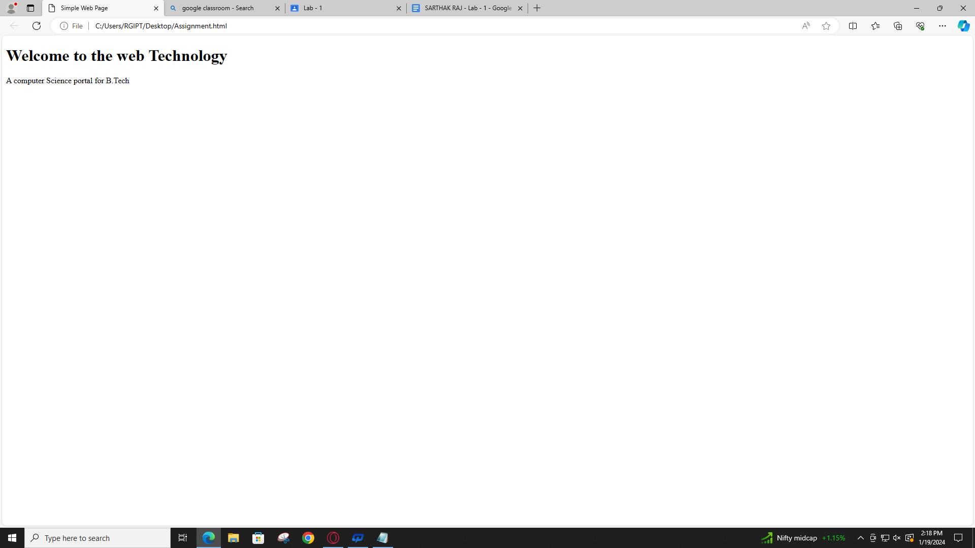

Question 2

<!DOCTYPE html>

<html lang="en">

<head>

<meta charset="UTF-8">

<meta name="viewport" content="width=device-width" initial scale="1.0">

<title> Simple Web Page </title>

</head>

<h1> Welcome to the web Technology </h1>

<h2> History of Web technology </h2>

<h3> Application of web Technology </h3>

<h4> Basics of web Technology </h4>

<h5> Know about HTML </h5>

<h6> Know about CSS </h6>

<h7> Books for Web Technology </h7>

<p> A computer Science portal for B.Tech </p>

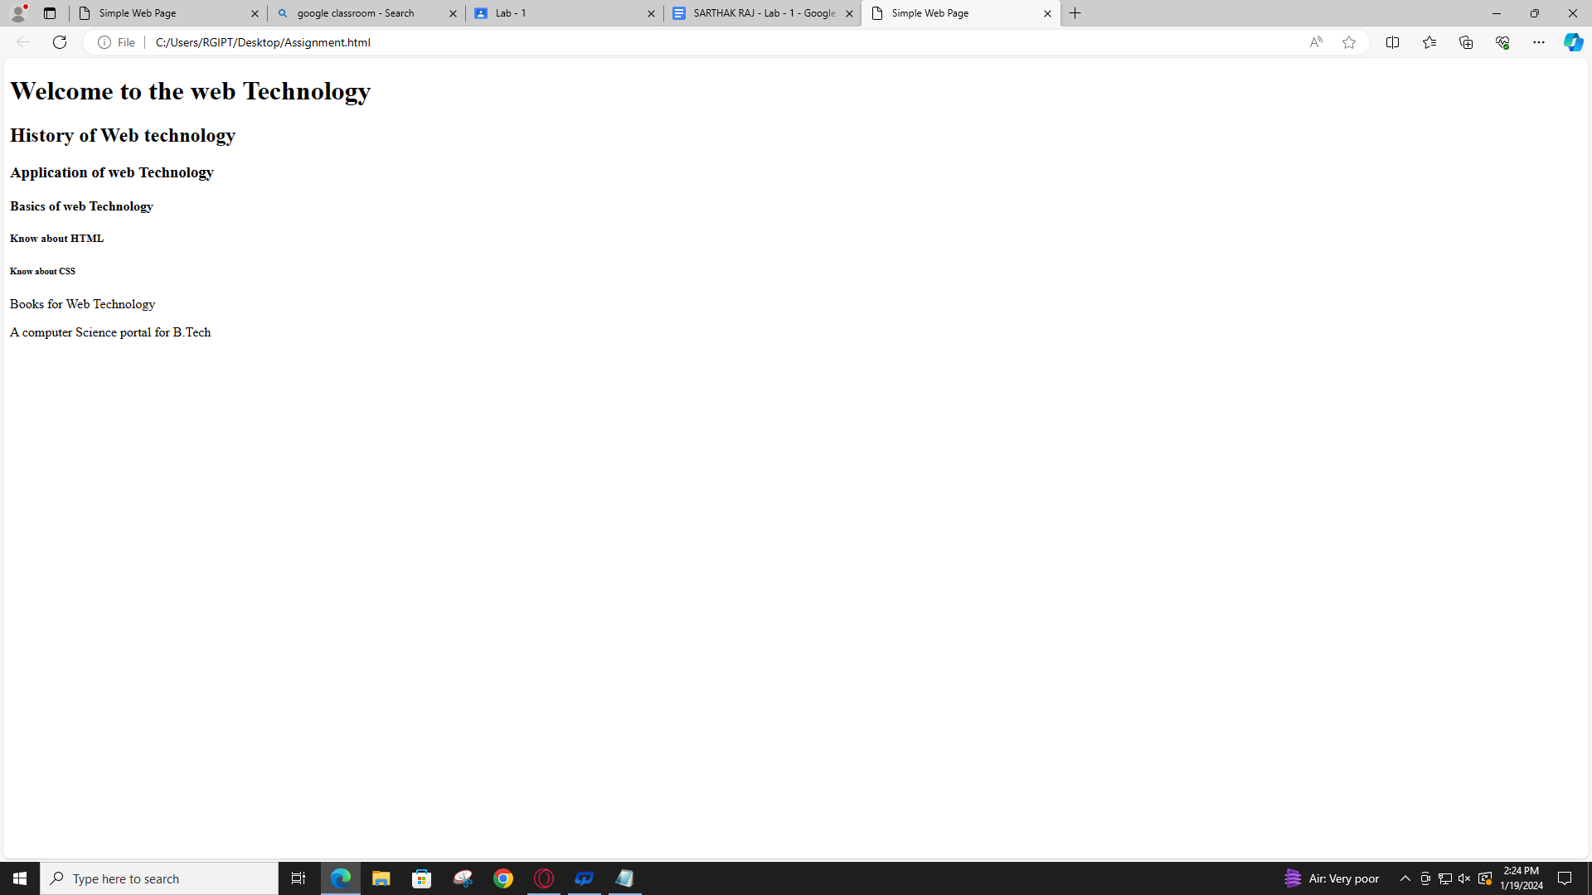

Question 3

<!DOCTYPE html>

<html lang="en">

<head>

<meta charset="UTF-8">

<meta name="viewport" content="width=device-width" initial scale="1.0">

<title> Simple Web Page </title>

</head>

<p> My Name is Sarthak Raj. </p>

<p> I am pursuing my Btech degree from RGIPT in the Information Technology Branch <br>

It is an institute of national importance located in Amethi district U.P </p>

<p> RGIPT provide degrees in multiple branches like Computer Science , Information Technology , Chemical </p>

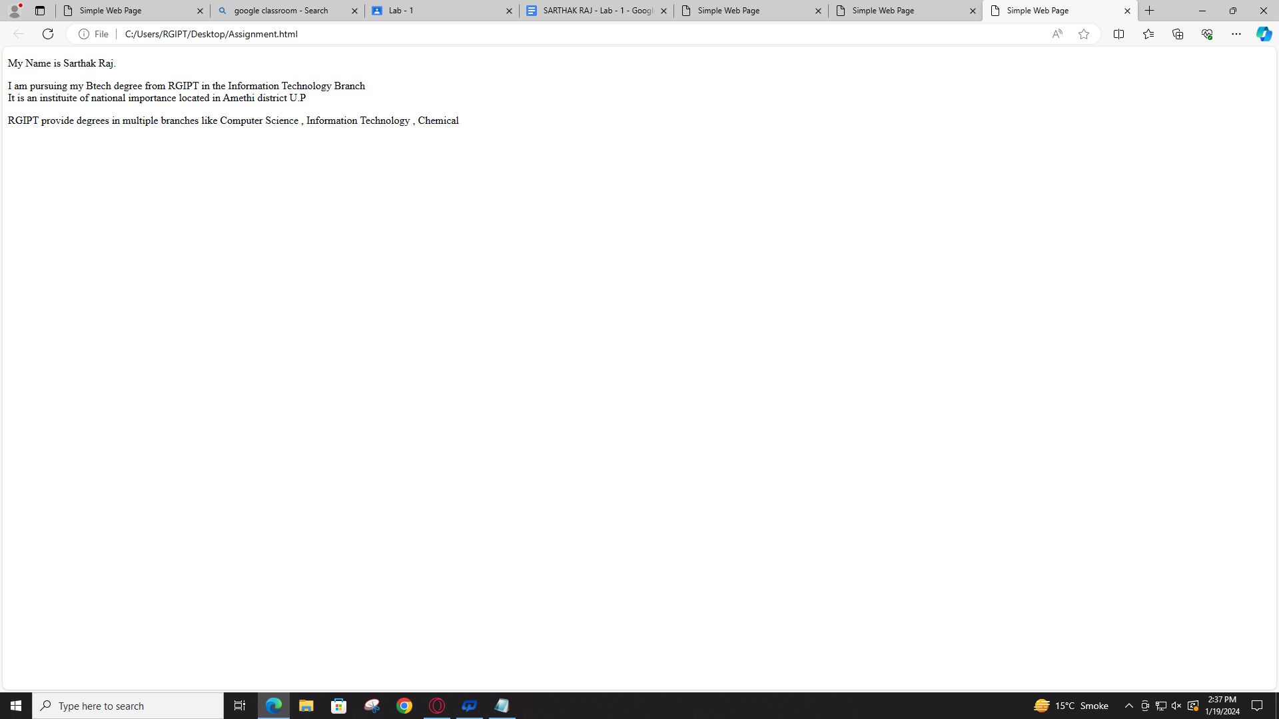

Question 4

<!DOCTYPE html>

<html lang="en">

<head>

<meta charset="UTF-8">

<meta name="viewport" content="width=device-width" initial scale="1.0">

<title> Simple Web Page </title>

</head>

<p> My Name is Sarthak Raj. </p>

<p> I am pursuing my Btech degree from RGIPT in the Information Technology Branch <br>

It is an institute of national importance located in Amethi district U.P

<p> RGIPT provide degrees in multiple branches like Computer Science , Information Technology , Chemical </p>

</p>

<p> My hobby and dream is to travel the world</p>

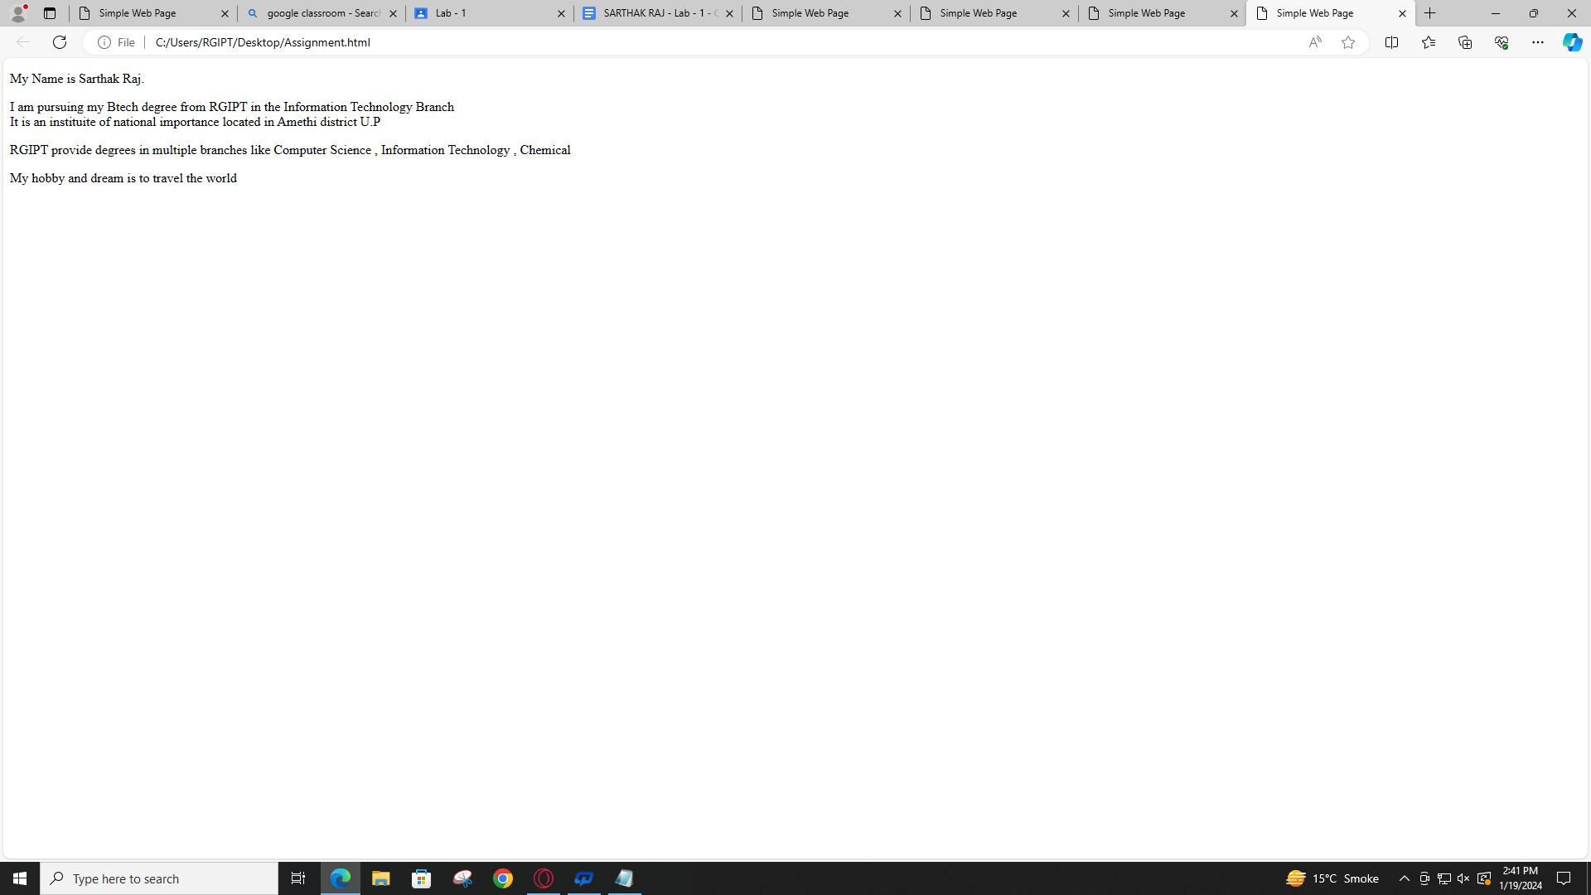

Question 5

<!DOCTYPE html>

<html lang="en">

<head>

<meta charset="UTF-8">

<meta name="viewport" content="width=device-width" initial scale="1.0">

<title> Simple Web Page </title>

</head>

<p> My Name is Sarthak Raj. </p>

<h1> My College</h1>

<p> I am pursuing my Btech degree from RGIPT in the Information Technology Branch <br>

It is an institute of national importance located in Amethi district U.P

<p> RGIPT provide degrees in multiple branches like Computer Science , Information Technology , Chemical </p>

</p>

<h1> My Hobbies </h1>

<p> My hobby and dream is to travel the world</p>

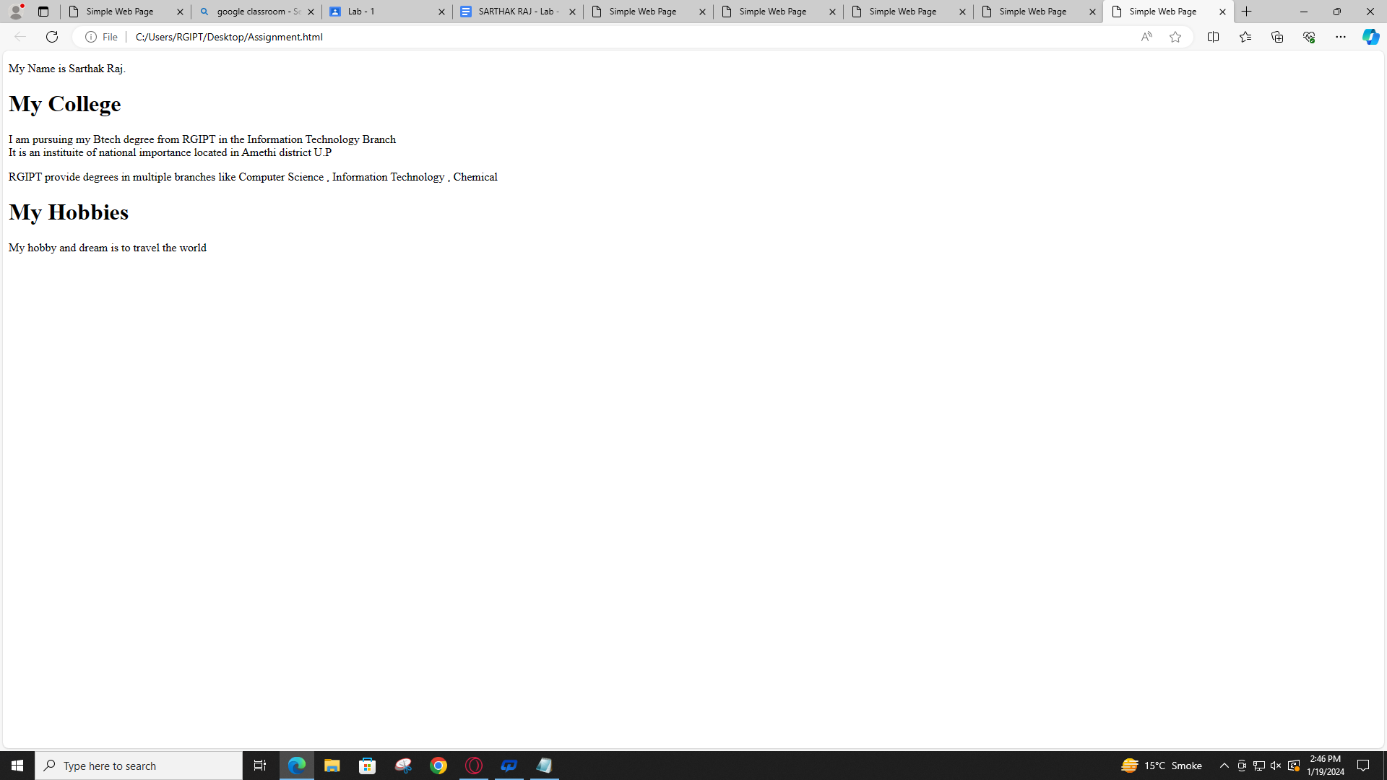

Question 6

<!DOCTYPE html>

<html lang="en">

<head>

<meta charset="UTF-8">

<meta name="viewport" content="width=device-width" initial scale="1.0">

<title> Simple Web Page </title>

</head>

<p> My Name is Sarthak Raj. </p>

<h1> My College</h1>

<p> I am pursuing my Btech degree from RGIPT in the Information Technology Branch <br>

It is an institute of national importance located in Amethi district U.P

<p> RGIPT provide degrees in multiple branches like Computer Science , Information Technology , Chemical </p>

</p>

<h1> My Hobbies

<p> My hobby and dream is to travel the world</p> </h1>

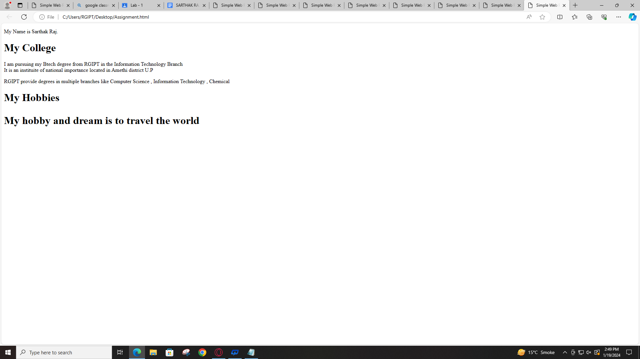

Question 7

<!DOCTYPE html>

<html lang="en">

<head>

<meta charset="UTF-8">

<meta name="viewport" content="width=device-width" initial scale="1.0">

<title> Simple Web Page </title>

</head>

<p> My Name is Sarthak Raj. </p>

<h1> My College

<h1> My Hobbies </h1></h1>

<p> I am pursuing my Btech degree from RGIPT in the Information Technology Branch <br>

It is an institute of national importance located in Amethi district U.P

<p> RGIPT provide degrees in multiple branches like Computer Science , Information Technology , Chemical </p>

</p>

<h1> My Hobbies

<p> My hobby and dream is to travel the world</p>

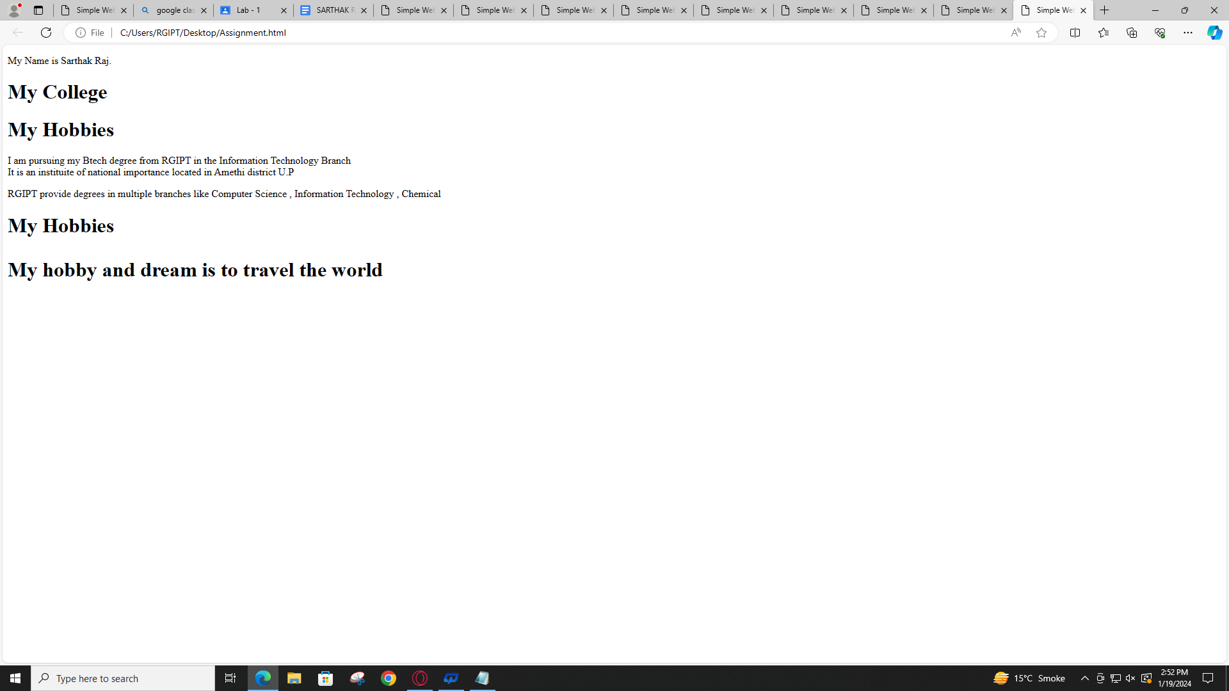

Question 8

<!DOCTYPE html>

<html lang="en">

<head>

<meta charset="UTF-8">

<meta name="viewport" content="width=device-width" initial scale="1.0">

<title> Simple Web Page </title>

</head>

<p> My Name is Sarthak Raj. </p>

<h1> My College

<h1> My Hobbies </h1></h1>

<p> I am pursuing my Btech degree from RGIPT in the Information Technology Branch <br>

It is an institute of national importance located in Amethi district U.P

<p> RGIPT provide degrees in multiple branches like Computer Science , Information Technology , Chemical </p>

</p>

<h1> My Hobbies

<p> My hobby and dream is to travel the world and do stargazing </p>

<img src="https://worlderz.com/wp-content/uploads/2018/05/stargazing-1.jpg" alt="Stars">

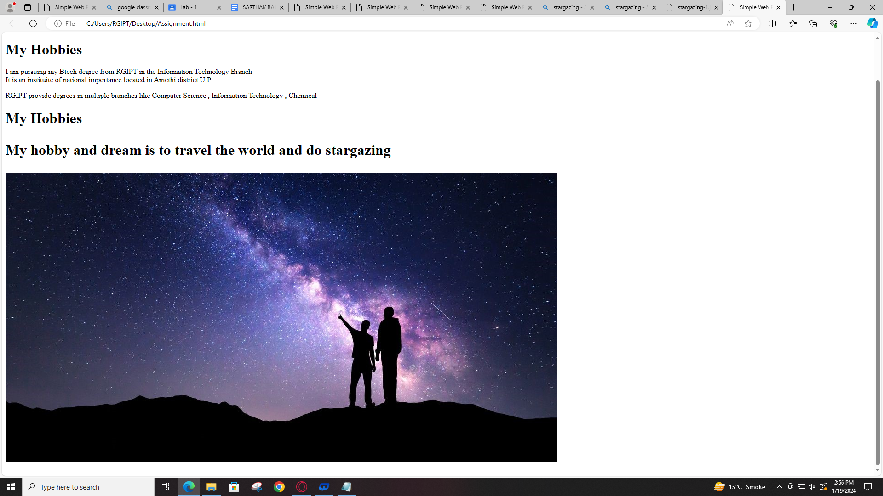

Question 9

<!DOCTYPE html>

<html lang="en">

<head>

<meta charset="UTF-8">

<meta name="viewport" content="width=device-width" initial scale="1.0">

<title> Simple Web Page </title>

</head>

<p> My Name is Sarthak Raj. </p>

<h1> My College

<h1> My Hobbies </h1></h1>

<p> I am pursuing my Btech degree from RGIPT in the Information Technology Branch <br>

It is an institute of national importance located in Amethi district U.P

<p> RGIPT provide degrees in multiple branches like Computer Science , Information Technology , Chemical </p>

</p>

<h1> My Hobbies

<p> My hobby and dream is to travel the world and do stargazing </p>

<img src="https://worlderz.com/wp-content/uploads/2018/05/stargazing-1.jpg" alt="Stars" height= "200" width="300">

